MARKING KEY YEAR 12 MATHEMATICS SPECIALIST 2018 TEST 2

CALCULATOR FREE

1.(a) .

|  |
| --- |
| **Solution** |
|  |
| **Specific behaviours** |
| ✓ makes denominator of fraction real  ✓ simplifies into required form |

(2 marks)

(b) 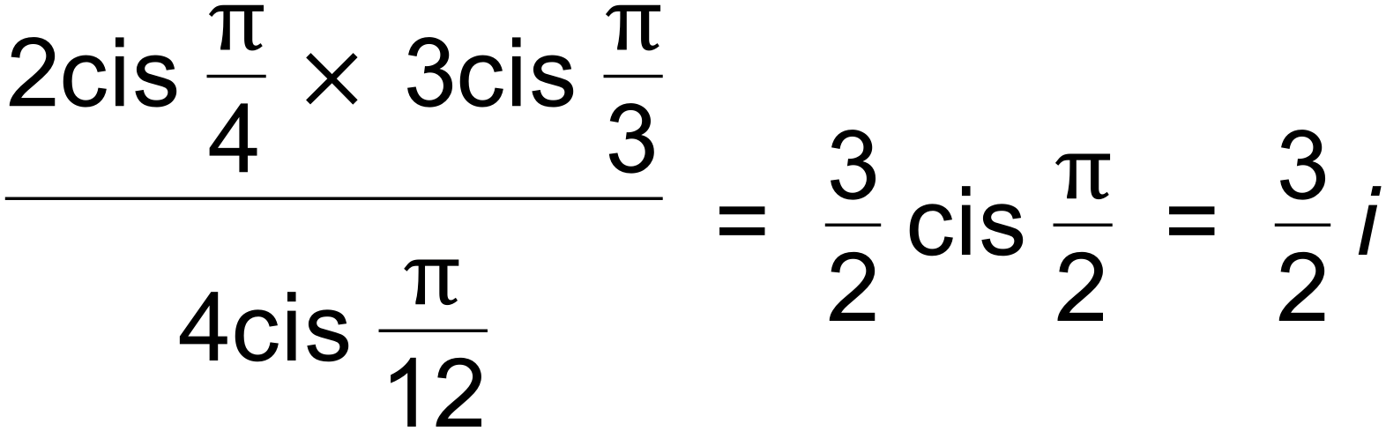 ✓✓ (2 marks)

(c) 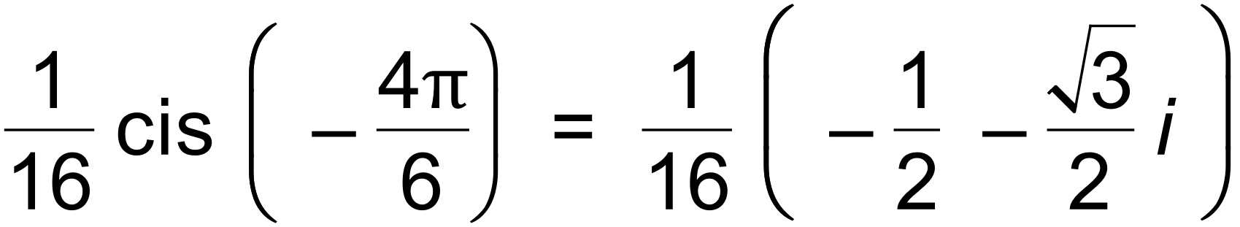 ✓

= 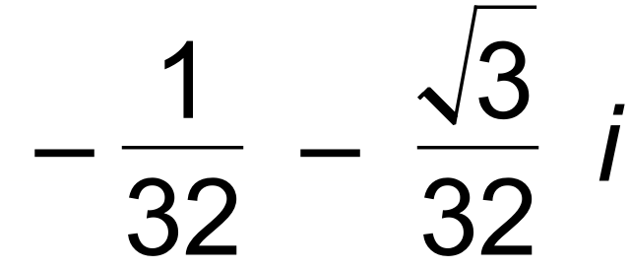 ✓ (2 marks)

(d) 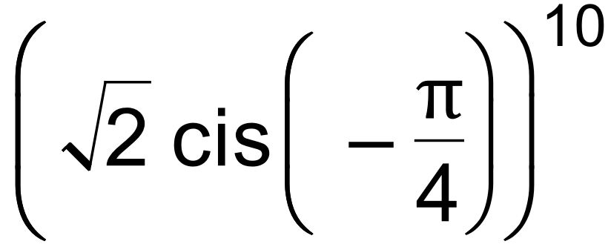 ✓

= 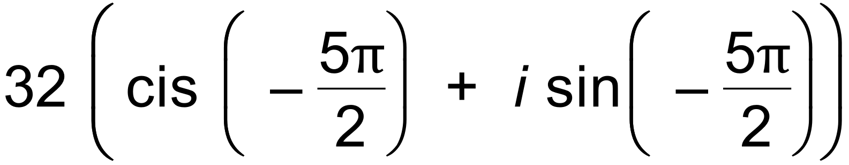 ✓

= 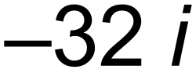 ✓ (3 marks)

2. *f* (−3) = 0 so *z* + 3 is a factor

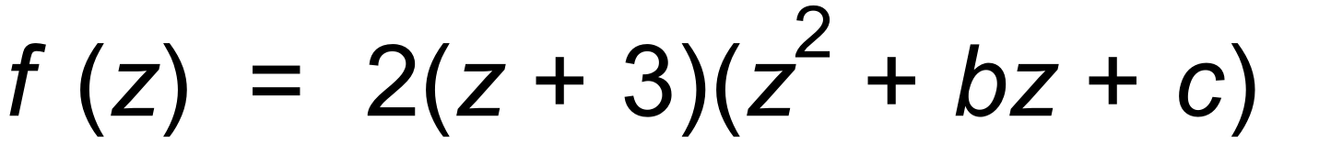 ✓

∴ *c* = 13 and *b* = −6 by equating coefficients or division

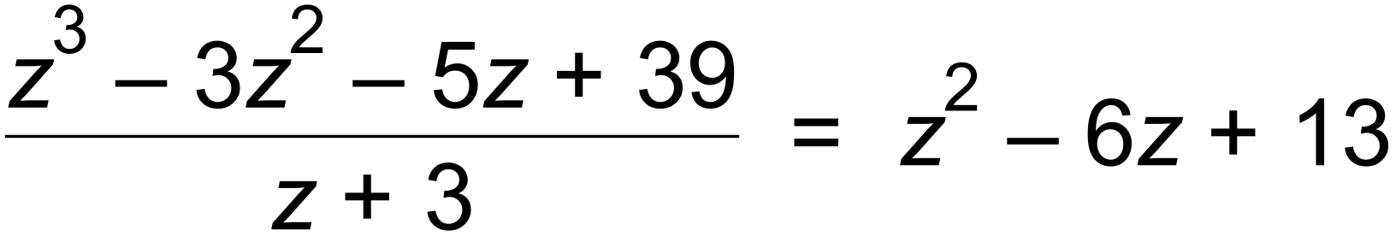 ✓

∴ 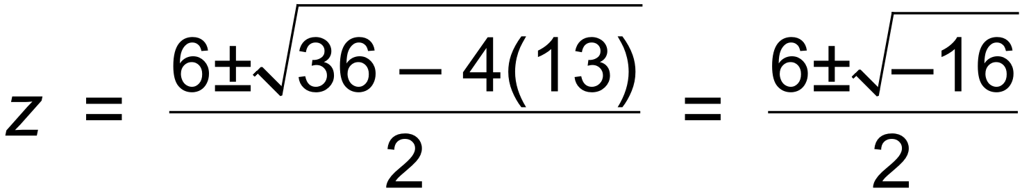 ✓

∴  ✓ [4]

**Question 3**

|  |  |
| --- | --- |
| Solution  and    (Or ) | |
| Marking key/mathematical behaviours | Marks |
| * Correctly states inequation for half plane above the line * Correctly states the inequality of the circular region * Indicates that it is the intersection of the two regions (ie uses “and”) * Indicates the boundaries correctly by using the appropriate symbol within each inequation | 1  1  1  1 |

**Question 4**

|  |  |
| --- | --- |
| Solution      , and    So the 5th roots of are: | |
| Marking key/mathematical behaviours | Marks |
| * converts  in polar form correctly * Determines  and * Determines the other four values of * Represents the five values of on the Argand plane * Accurately places the roots on a circle with a scale indicating the radius | 1  1  1  1  1 |

Question5

=

=

* Uses the correct expression for in terms of a, b
* Determines the correct wxpression for in terms of a and b
* states that
* States that

Calc Assumed

Question 6 (6 marks)

The complex numbers and are shown on the Argand diagram below.

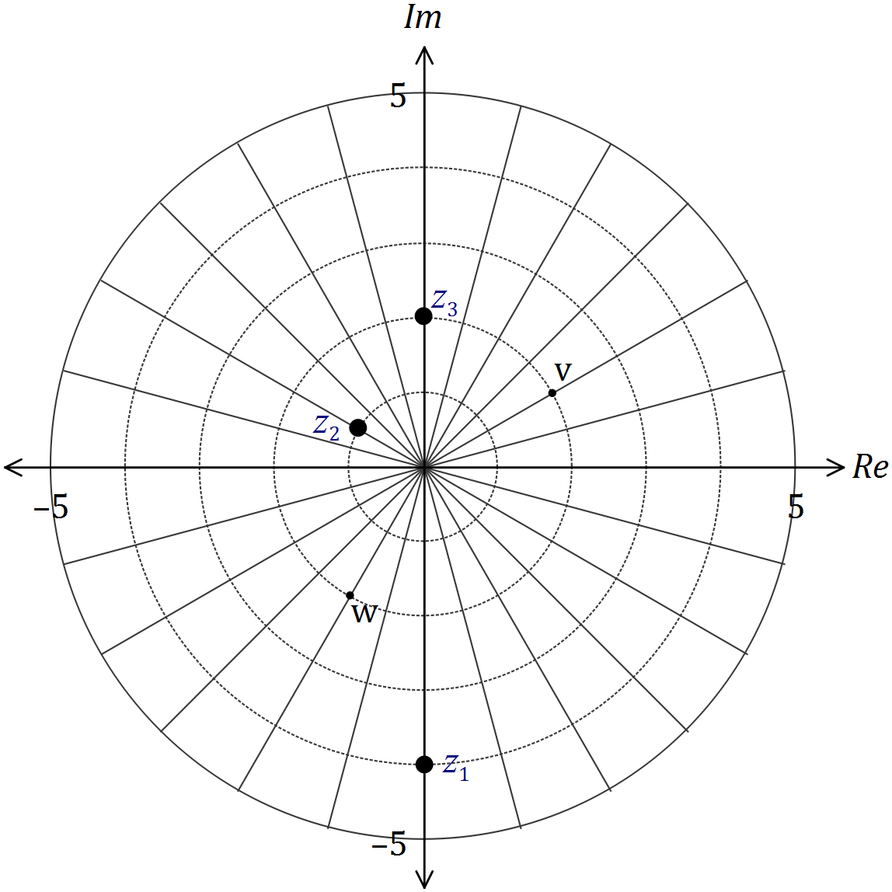

On the diagram, clearly mark the complex numbers

(a) . (2 marks)

|  |
| --- |
| **Solution** |
| Multiply moduli and add arguments |
| **Specific behaviours** |
| ✓ correct modulus  ✓ correct argument |

|  |
| --- |
| **Solution** |
| Divide moduli and subtract arguments |
| **Specific behaviours** |
| ✓ correct modulus  ✓ correct argument |

(b) . (2 marks)

(c) . (2 marks)

|  |
| --- |
| **Solution** |
| Rotate 90° anticlockwise and then treat as vector addition |
| **Specific behaviours** |
| ✓ correct modulus  ✓ correct argument |

7 (a) | *z* − (−1+2i) | 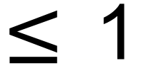 is the region inside the circle centre (−1, 2) and radius 1

| *z* + i | 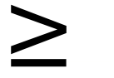 | *z* − (2 + i) | is the region on one side of the line *y* = −*x* + 1,

containing (1, 1)

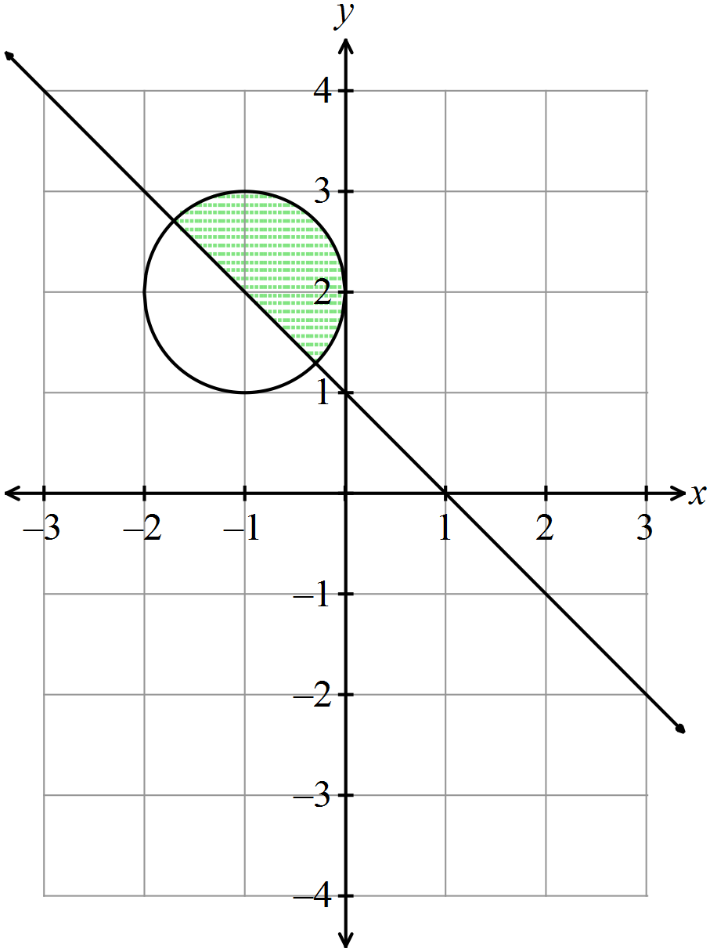

✓ circle

✓✓ line

✓ region

(b) 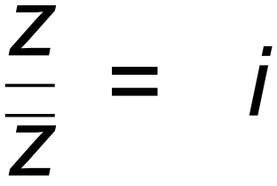 is the line *y* = *x*, since *x* + *y*i = i(*x* − *y*i) = *y* + *x*i

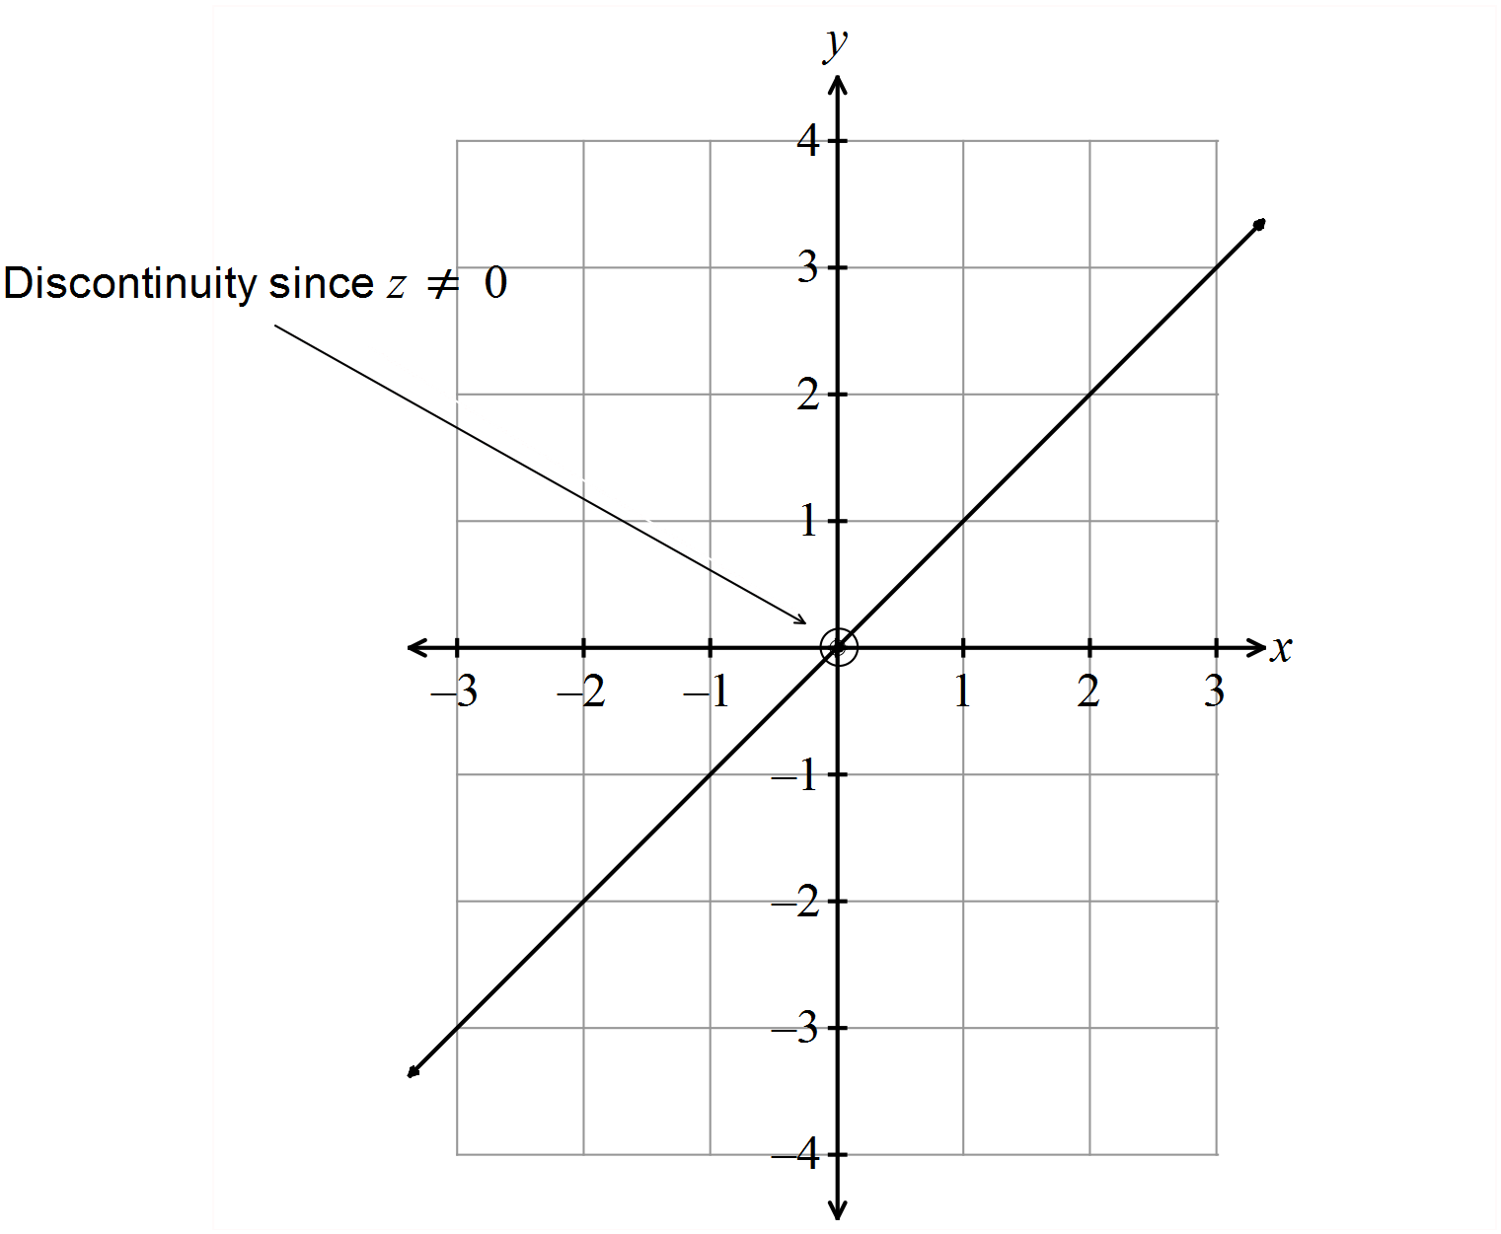

✓✓ line x=y

✓open circle at zero

(c)

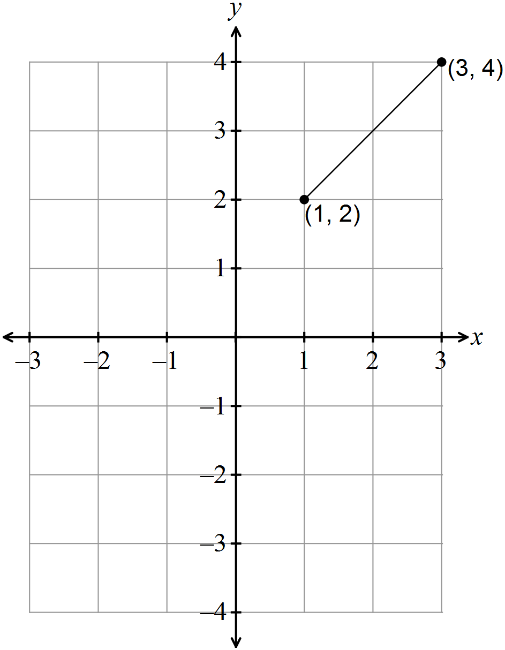

✓ endpoints

✓ correct line segment

[8]

8.A subset of the complex plane, a circle with centre , is shown below.

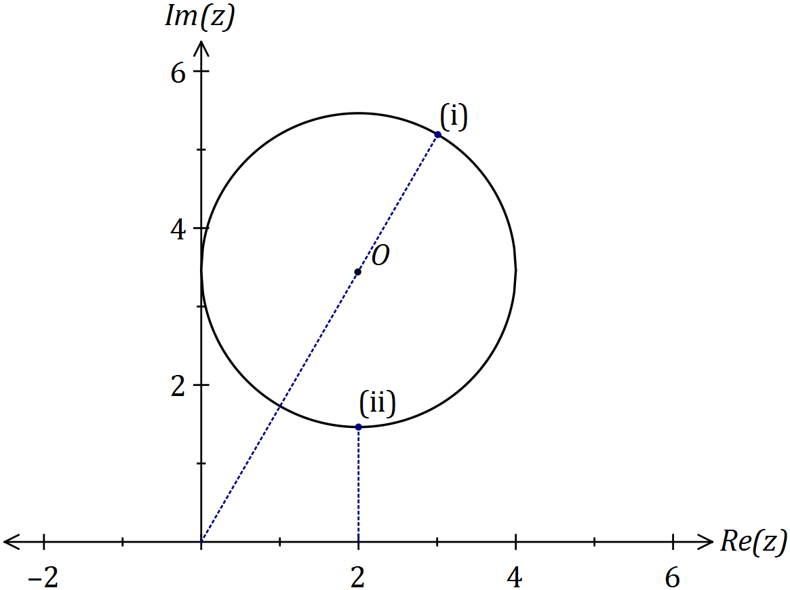

(i) Mark the position in the plane where is maximised. Label this point (i).

(1 mark)

|  |
| --- |
| **Solution** |
| Maximum when lies on circumference at greatest distance from origin. |
| **Specific behaviours** |
| ✓ indicates location |

(ii) Mark the position in the plane where is minimised. Label this point (ii).

(1 mark)

|  |
| --- |
| **Solution** |
| Minimum when lies on circumference at closest point to (2, 0). |
| **Specific behaviours** |
| ✓ indicates location |

(iii) If the subset shown is , determine the maximum and minimum values of . (3 marks)

|  |
| --- |
| **Solution** |
| Maximum:  Centre:  Minimum: |
| **Specific behaviours** |
| ✓ states maximum  ✓ indicates argument of centre  ✓ uses symmetry to determine minimum |

9. (a) By De Moivre’s theorem

✓

✓

✓

✓

✓

(b) Let , then ✓

when ✓

and

✓ [8]

**Question 10**

|  |  |
| --- | --- |
| Solution  Let  So | |
| Marking key/mathematical behaviours | Marks |
| * Substitutes  into given equation * Substitutes  into given equation * Compares real and imaginary parts * Determines * Determines the two values for * States values of | 1  1  1  1  1  1 |